The following 10 questions were developed for preparation of Kadir Has University's New Media Studies Conference - Data Journalism workshop exam.
Name:
Surname:
1-What type of data is 'Size:190cm'?
a) Discrete Data
b) Categorical Data
c) Continuous Data
d) Qualitative Data

2- How can you get hold of unpublished government data?
a) Freedom of Information Requests
b) The library of any University
c) Press Releases
d) The yellow Press

3) The following excel spreadsheet is an excerpt taken from the Worldbank data. Which country is shown to have the highest birth population?

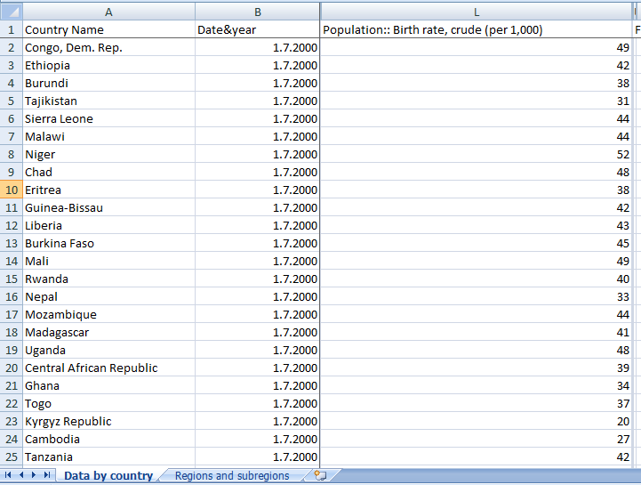
Answer:
4) A formula in a spreadsheet starts with the character:
- &
- %
- =
- £
5) Which presentation should you choose if your data has a strong geographical reference?
a)Piechart
b)Bar chart
c) A map
d)Tap dance

6) If the median income is 20.000 TL, then the following is true:
a) The average income is 20.000 TL
b) 50% of people earn 20.000 TL or less
c)It is half the maximum income
d)Don't Know
7) Which step is not commonly taken in answering questions with data?
a)Finding Data
b)Drawing
c)Visualising Data
d)Analysing Data
8) What do you not need to tell a Datastory?
- Key points for storyline
- A web-server
- Data supporting the storyline
- An interesting dataset

9) What is a Datacatolog?
a) Software to view data
b)A service collecting datasets
c)Online shopping form
d) Datacatalogs are made of people

10) Which of the following is not a spreadsheet formula?
- Max
- Min
- Abs
- Mean

